MTConnect Agent Remapping

This is aMTConnect Agent implementation that accepts a couple of different device descriptions and remaps the tags and enumerations. The agent reads one or more different types of SHDR, remaps values according to the devices configured ( ).

It also allows the administrator to reconfigure the MTConnect agent AFTER intstallation, by modifying the Config.ini file in the installation directory (typically C:\Program Files\MTConnect\MTCAgentShdrTagRemapper).

## Installation

Of interest in the installation is the devices SHDR setup screen. Below is a window screen shot of a configuration with two devices (M1,M2) of types (Mazak,TechSolve) with host IPS of 127.0.01 and port numbers (7878,7879). Type device types are limited to the names above the field: Mazak, Fanuc,TechSolve, MakinoT4. These devices each have their OWN naming convention which requires a remapping into a standard representation. (Templates for these types are under the installation folder in the Devices directory – each type has a "txt" file describing a device template, and an "ini" file giving the tag renaming and the enumeration mapping.

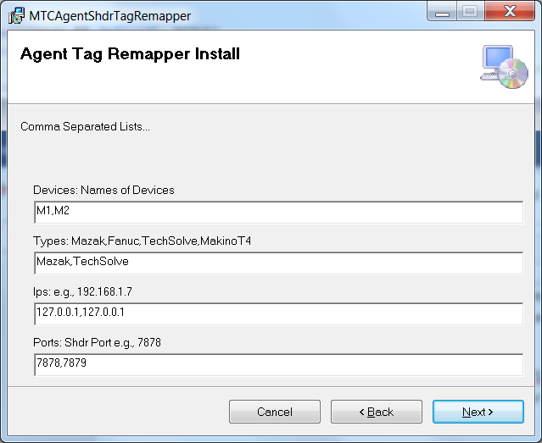

At installation time, the MTConnectAgent service name and http for the web server are configurable in the next dialog:

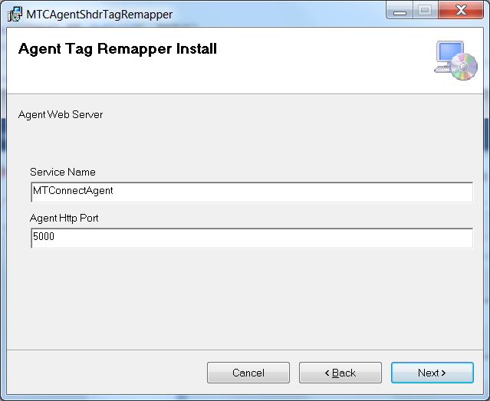

## Post-installation Configuration

After installation an administrator can change configuration in the Config.ini file by changing 5 fields:

[GLOBALS]

Config=NEW

The Config parameter tells the agent to generate new Devices.xml and Agent.cfg files using the information defined later in the Config.ini file. The parameters: MTConnectDevice, DeviceType, Ip, and Port define the new configuration and are comma separated lists. The order in each field is used to define the configuration (which should be obvious).

[GLOBALS]

. . .

# Specifies how Devices.xml and Agent.cfg files to be configured

MTConnectDevice=M1,M2,M3

DeviceType=Mazak,TechSolve,Fanuc

Ip=127.0.0.1, 127.0.0.1, 192.168.0.1

Port=7878,7879,7878

After you specify a new configuration, the Devices.xml and Agent.cfg file will be updated.

## Service Installation

The agent is installed into the Service Control Manager (SCM) with the given service name. It is setup as Automatic but IS NOT STARTED. You can manually start the service using the SCM.